Identification Of Gated Communities In gypt
Abstract:
GCs witnessed a dramatic wide spread in Egypt, which appeared in different ways reflecting how planning process affects the formulation of GCs inside new towns urban fabric. The aim of this paper is to explore the singularities of GCs in Egypt as well as to define the ways GCs are identified and defined in Egypt. The paper concerns the patterns that are situated inside metropolitan areas especially those types that are planted inside new towns urban fabric and their future extension. To achieve this aim, this paper proposes a GIS data base for GCs that are located inside Greater Cairo Region new towns. The aim of the survey is to quantify the scale and type of GCs, to deduce the ways GCs are identified and defined in Egypt, to explore how planning process affect the formulation of GCs in Egypt. This paper is divided into three main sections. In the first section, GCs are traced on plans of GCR new towns. In the second section, the nature, main features, patterns and characteristics of GCs are documented and deducted in new towns in Greater Cairo Region. In the third section, the behavior of state in inserting GCs in Egypt is explored. The survey is based on PhD dissertation, examined in 2011; the survey is established by the start of 25 Jan revolution. It explores how Mubark Authorities affected the formulation of GCs spread in Egypt.
Aim:
The aim of this paper is to explore the singularity of GCs in Egypt exploring the ways GCs are identified and defined in Egypt. This will lead to a greater insight into how planning process affects the formulation of GCs inside new towns urban fabric. The survey quantifies the scale and type of GCs in Egypt:
- Establish the numerical identification of the geographic coverage of GCs inside GCR.
- Identify the broad types of GCs in GCR, both already built and those have received planning permission
- Examine the attitudes of planning authorities to GCs.
- Tracing the impact of GCs on urban fabric and social structure
Methodology:
In order to achieve this aim, the study proposes GIS database for GCs that are located inside Greater Cairo Region new towns. This study based on a survey processed at 2011, at the end of the previous political system of Mubarak. The methodology of this research is divided into three main sections:
- Data Identification, data grouping and tracing of GCs on GCR using GIS.
- Data Documentation of GCs individual, location and grouping characteristics.
- Data Analysis of GCs most common characteristics within site into how planning process affects the formulation of GCs inside new towns urban fabric.

Identification of GCs involves a systematic survey for GCs from different sources like, newspapers, real estate agencies (either through a direct contact or through the internet), statistical data from local authorities, field visits to these cities to collect data, and aerial photographs. All information is gathered and organized in individual files for each Gated Community. Then the grouped information and data are traced, characterized, and imported in Geographic Information System (GIS).The study area includes the five municipalities surrounding Greater Cairo Region: Six October, El Sheik Zayied, El Obour, El Shourouk, and New Cairo (Figure 1).
466 GCs have been identified in the study area. Due to some difficulties in approaching data for all identified GCs and the fact that some GCs are still under construction or the building permits are not available for consultation. The number of GCs with a fully completed data came to 228.
Fig. (2): Sample of GCs initially identified (on the left) and fully characterized (on the right) in GCR
The following figure presents the flourishing of GCs inside GCR new towns, with tracing different communities and their individual, location allocation and grouping characteristics Fig.(3) and table (1).
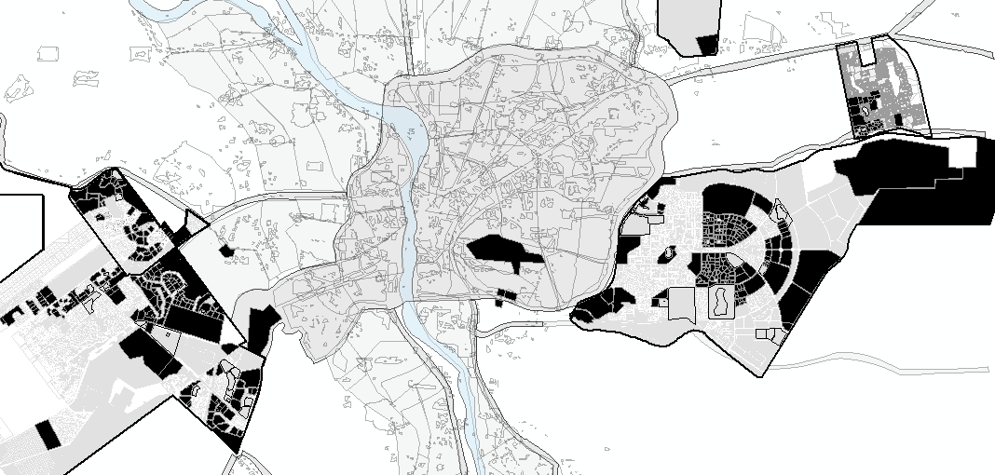
Fig.(3): GCs flourishing inside GCR new towns.
The following part explores the singularities of GCs in Egypt; it explores documentation of GCs individual, location and grouping patterns, table (2, 3, 4). Each Individual, location and grouping characteristics will be explained in the following section.
- DOCUMENTION OF GCS’ CHARACTERISTICS IN GCR NEW TOWNS
After tracing GCs inside GCR new towns, and through the proposed GIS empirical data, this section intends to document their classifications and typologies, and present their singularities in GCR - Egypt. This explores how far their expansion contributes to recent patterns of urban form and to the changing structure of this metropolitan area. To document GCs in Egypt we need to document their main characteristics and where they are being proposed and built, with deducing the most common individual, location and grouping characteristics in the different municipalities of Greater Cairo Region. Documenting GCs physical characteristics involves three sections:
- Individual characteristics represented in internal pattern (area, density, size, housing type, land use type, and street network type), and boundaries (area, land use, type, and number of gates).
- Location allocation characteristics represented in general location allocation preferences and adjacent public community street network, housing type, and land use type.
- General grouping method characteristics represented in (proximity, division, ...)
  - GCs Individual Characteristics
Individual characteristics influence the achieved development for their residents, as long as they affect a restricted area isolating it from the city. Although, GCs in micro scale are mostly characterized with definite features in street network, land use, and housing pattern that constitute its behavior in urban development; rather these features can show some range of variation in their characteristics.
This section introduces GCs classification according to individual characteristics, which can be classified under the headings of (area, density, size, land use type, housing type, street network type, services patterns, landscape patterns, and boundary patterns). A classification using cluster analysis with natural distribution curve is done for each of these individual characteristics to classify it into three types, two extremes and a mid-one. The most common characteristics of GCs then can be measured.
    - GCs Land-use Patterns
GCs could be classified according to Land use patterns. This varies as follow:
- Land use variation range between single (87%), semi (8%) and varied (5%).
- Land use type range between residential (89%), and residential with commercial (4%), recreational (4%), and administration (1%).
- Land use density range between low, middle and high.
It could be concluded that the most common land use type are single use mostly residential.
    - GCs Housing Type Pattern
GCs could be classified according to housing type patterns. This varies as follow:
- Housing variation range between single (93%), semi (3%) and varied (11%) income area.
- Housing type range between low (6%) , middle (17%) and high (78%) income area.
- Housing density range between high (6%), mid (12%), and low (82%) density area.
It could be concluded that the most common housing type are single mostly high level.
    - GCs Street Network Pattern
GCs could be classified according to street network patterns. This varies as follow:
- Street network pattern range between grid (27%) and treed hierarchical (73%).
- Street network pattern range between fine grained (16%) and super block (84%).
- Street network pattern range between continuity and discontinuity with urban fabric.
It could be concluded that the most common street network pattern are treed inward oriented.

    - GCs Services Pattern
There is a wide range of services that are supposed to promote the functionality of the community. GCs range from having incomplete services (68%) to semi complete services (24%) to constitute complete neighborhood with complete services (8%). It could be concluded that GCs are most commonly incomplete services, which raise debate about their ability to promote the functionality of the community.
    - GCs Facilities and Amenities Pattern
There is a wide range of amenities and facilities that are supposed to promote the sociability of the residents, which could range among a playground, a swimming pool and/or tennis court, health-club, gym and others. GCs range from having few amenities (71%) to semi complete (18%) to constituting complete amenities (11%). It could be concluded that GCs are most commonly incomplete amenities and facilities, which raise debate about their ability to promote the sociability of the community.
    - GCs Landscape Pattern
There is a wide range of landscape patterns that are supposed to promote the environmental quality of the community. GCs range from having few landscape features (12%) to closed gardens (83%) to constituting complete golf cources (5%). It could be concluded that the most common landscape pattern in GCs is closed gardens, which explain their ability to promote the environmental quality of the community.
    - GCs Boundary Characteristics
GCs could be classified according to variation in boundary pattern. which vary as follow:
- Area of GCs range between (road closure, small closed condoms, Entire neighborhood, Sector of the city, and extension of the city).
- X-Y ratio ranges between rectangle and square.
- No. of entrances range between low, mid and high number of entrances.
- Type of entrances range between free access, car access, and totally controlled.
- Type of fences range between land use, and no use.
- Type of fences range between wall, fence, combined

The wide range of these individual characteristics gives rise to a variety of impacts on urban development. Any examination of the impact of GCs on urban development should explore the impact of each of these individual characteristics.
  - GCs' Location / Allocation Characteristics
The insertion of GCs inside different locations influences its relevant impact on the achieved development for its residents and adjacent community residents. As location allocation of gated private area impact public area subdivision, unity and integrity, so it affects its services, public spaces, and street network. Wrong location choices could create closed public areas with no gates, an area located between groups of GCs, this public area could face negative impacts, and it is restricted and isolated without choice. Hence, the good choice of location impacts their role in urban development.
This section explores and traces the extent GCs tend to located and grouped in Egypt; how they collectively contribute to recent patterns of urban form and to the changing structure of GCR new towns.
In order to discribe and classify any urban development pattern, according to location pattern, it is concluded in variables that are related to adjacent area characteristics represented in (street network, housing type, land use type) and other according to insertion method. A classification using cluster analysis with natural distribution curve for each of these location characteristics to classify it into three types, two extremes and a mid-one. The most common location and grouping characteristics of GCs then can be deduced.
    - Location / allocation Method
        - Location in Reference to City Scale
GCs could be classified according to location in reference to city scale, which varies between central, mid and periphery location.
        - Location in Reference to Sector Scale
GCs could be classified according to location in reference to sector scale, which varies between central, mid and periphery location.
      - location Adjacent Urban Fabric Patterns
location classification according to adjacent area patterns (street network pattern, housing pattern, land use pattern). Especially the issue of similarity and continuity between micro private community and adjacent public community.
        - GCs Adjacent Area Land use Patterns
GCs could be classified according to adjacent area land use patterns, that varies as follow:
- Adjacent to Land use type which varies between (residential, admin or other).
- Adjacent to land use variation varies between (single or no variation or mixed).
- Adjacent to Land use density varies between (low, mid or high).
- In Continuity or dissimilarity of land use type with adjacent community housing type.
        - GCs Adjacent Area Housing Patterns
GCs could be classified according to adjacent area housing patterns that vary as follows:
- Adjacent to lower income area, mid income area or high income area.
- Adjacent to high density area, mid density area, low density area.
- Adjacent to separate income area, mixed income area.
- In continuity or dissimilarity of housing type with adjacent community housing type.
        - GCs Adjacent Area Street Network Pattern
GCs could be classified according to adjacent area street network pattern, which varies as follow:
- Adjacent to low porous super block and high porous fine grained street network pattern.
- Adjacent to regional road, arterial road, collector road or local road.
- In continuous with adjacent streets or in contrast with adjacent streets.

The wide range of location / allocation characteristics gives rise to a variety of impacts on urban development. Any examination of the impact of GCs on urban development should explore the impact of each of these location / allocation characteristics.
    - GCs' Grouping Characteristics
The relation between GCs ratio and relation with public urban form is the main heading of this exploration and classification. This section explores and traces the different ways GCs collectively contribute to recent patterns of urban form and structure of GCR new towns. Planners' choices of these grouping characteristics formulate the impact of GCs on urban development not only private community, public community, but also the overall community. In order to discribe and classify any urban development pattern, and define its most common characteristics according to grouping pattern we can classify it under heading of (area, location, size, xy ratio, proximity, division, and clustering) of grouping method. Gated Community could be classified according to grouping method in the following types:
        - Division of Grouped Units: (Continuous - Segregated)
GCs could be classified according to grouping division patterns, which vary between continuous and segregated.
        - Clustering of Grouped Units: (Clustered - Evenness)
GCs could be classified according to grouping clustering patterns, which vary between clustered and evenness.
        - Proximity of Grouped Units: (Attached - Spaced)
GCs could be classified according to grouping proximity patterns, which vary between attached and spaced.
        - Grouping Public to Private Ratio and Distribution: (Totally open - Totally Gated)
Gated Community could be classified according to grouping public to private ratio patterns, which varies between totally public and totally private.

The wide range of grouping characteristics gives rise to a variety of impacts on development. Any examination of the impact of GCs on urban development should explore the impact of each of these grouping characteristics to reach the best choices.
- EXPLANATION OF THE PHENOMENON IN EGYPT
This section includes GCs data analysis with introducing exploration for the phenomena in Egypt, in two steps. The first introduces explanation of the most common individual, location and grouping characteristics. The second gives sight into how planning process affects the formulation of GCs inside new towns urban fabric. Based on the previous investigation, reviews and classification of GCs characteristics, this section can sum up most common characteristics of GCs in Egypt, and explore the singularities of GCs in Egypt as in the following:
    - Explaining GCs Individual Characteristics
Based on the previous empirical study, this section concludes that GCs most common individual characteristics in GCR are characterized by the following: Spatially, GCs encourage inward oriented treed street network (63%), super block patterns (72%), barriers that are mostly walls, and low number of access points. Socially, GCs are mostly homogeneous sole housing type (around 93%), mostly high(around 80%), encourages low housing densities (around 82%). This can be explained in three reasons:
First: Le-Goix argued for GCs as club economy that refer to developers implicit selection of the owners as selective club membership, which explain the homogeneity of the neighborhood.
Second: The high cost of GCs housing units, explain restricting their un-affordability for high and upper mid classes.
Third: As developers tend to create GCs in high class luxurious villas with large area, this make GCs tend to be constructed in low density.
Main characteristics |  | GCs
Land use pattern | Type | Single land use type(87%), mostly residential (87%)
 | Density | Low denisty
 | Mix | No variation so no mixing
Housing pattern | Type | Single housing pattern (93%), mostly high (80%)
 | density | Low denisty (82%)
 | Mix | No variation so no mixing
Street pattern | Type | Treed (cul-de-sac) (62%)
 | orintation | Inward orinted (72%)
 | with external | contrast with the surrounding environment
Services and amenities | Services | In complete (78%)
 | Facilities | In complete (71%)
 | Amenities | In complete (71%)
Table (5): Most common individual characteristics of GCs In Egypt.
    - Explaining GCs Location and Grouping Characteristics
Based on the previous empirical study, GCs in GCR are characterized by the following: Spatially, GCs tend to be located and grouped in totally gated private areas, with super block street network patterns (90%). Socially, GCs tends to locate neighbor to single housing type and mostly high level (79%). This can be explained in three reasons:

First, Le Goix (2009), argued that GCs are located within a consistent social environment, within every kind of middle class and upper-class neighborhoods. Behavior of GCs is combined with puffer zones of choices to be located adjacent areas of high class and gated areas.
Second, GCs tend to affect the property values of the surrounding area that increase housing value and restrict the affordability of its adjacent area to high-class residents.
Third, Walid N A Bayoumi (2009), argued for exclusion through housing, he explains the behavior of the developers in their choices of GCs location to be located in areas of high class or even near gated areas.
This study traces some other cases, such as Lake View and Katamia hills that are located in city center of New Cairo city. In addition, some cases like Golf El-katamia and Arabela that are located neighboring to low income housing area. It is evident that GCs in Egypt did not obey a role in size, location or distribution, inside urban fabric. They tend to be located on local, distributor, arterial or even regional street, which indicate the negative visual impact that gates could impose on not only regional streets but also the local roads that was supposed to be for pedestrians or residents safe movement.

 |  | Spatial characteristics
Street pattern | Street network | Tend to locate in gated Super block areas ( 90% )
 | Urban spaces | No public spaces
 | Walk ways | No
Housing pattern | Housing pattern | Tend to locate in high class area ( 79% )
 | Housing density | Low density
Services and amenities | Land use | No use
 | Land use Variation | Just walls
 | Services | Removed from public and become in ward oriented
Table (6): Most common location and groupingcharacteristics of GCs In Egypt.
    - Planning Process Impact on the Formulation of GCs
This section gives sight into how planning process affects the formulation of GCs inside new towns urban fabric. Many transformations have been carried out without taking proper cautions of their impacts. The government gives up to developers’ pressure allowing them to make changes in urban fabric, changing its urban form and structure, for example Rehab 1&2 have combined increasing more gated areas.
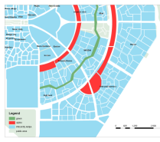  Proposed public road network and urban form In new Cairo city macro urban fabric | 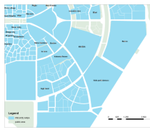  Transformed road network and urban form In new Cairo city, from public fine grain to a gross urban fabric and a super-blocks | 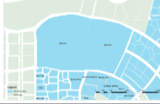  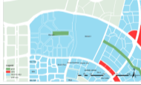
Fig. (4): Transformed urban fabric in micro internal scale
In addition, many large area projects like Barwam, Mividia and Hyde Park exceed what is proposed in previous developed master plans. This change transformed urban fabric of new Cairo city from public road network to a structure of private inaccessible super-block. The government is involved largely in developing this phenomenon, by discouraging the new development to be part of the overall image of the society, on the contrary they increases fragmentation, and hence increase the negative impact on public life in the city.
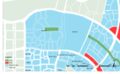 | 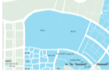 | Authority did not take in their mind the impact of increasing GCs area. They neglected its impact on the continuity of city urban space network, green lines network, services, and social equity.  Authority does not object if Gated Community area is extended and the closed area is increased, with containing and privatizing the in between street and hence increase gated area and parameter length, which could impact permeability, accessibility and cause longer alternative paths which often take longer time to reach and cross through the gated area. Merging El Rehab 1 and 2 cut the accessibility and permeability for anyone who wants to inter new Cairo city from Cairo Suez road. In addition, Rabwa Gated Community.  Authority neglected the relationship between change in gated area and its location inside urban fabric. They permit the developer to increase GCs size, with no reference to its location. Authority does not object to erect any residential Gated Community inside city center.  Most of Services areas, (that were planned in previous plans to be services for open neighborhoods) are converted into gated area (residential gated areas or even to be private clubs). Authority decision makers assumed that regulating 8-12% services area would be enough for their residents and could substitute services area before constructing barriers.  The authority is not aware of the overall negative impact of this pattern of development on the overall city urban structure.
Fig. (5): El Rehab, befor and after increasing gated area.
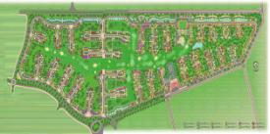
Fig. (6): El Rabwa after increasing area.
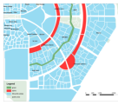 | 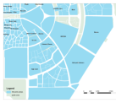
Fig. (7): Large GCs with no reference to location
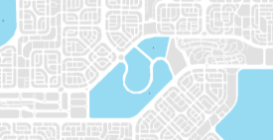
Fig. (7): Lake veiw, setteled in city center.

b: Transformed urban form In new Cairo city, from public fine grain to super-blocks | a: Proposed public road network and urban form In new Cairo city macro urban fabric
Fig. (8) -: Transformed urban fabric in macro scale from connected city to divided city.
Another case study in Sheikh Zaied city explores the acts of the authority as follow:  1: Gating open area.  2: Increasing Gated area.  3: Convert service area into a private gated residential area.  4: Impacts on left public area. | 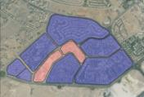 | 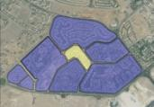
 | a): Proposed old plans | b): Impose private area
 | Fig. (9) -: Different cases that explore the impact of authorities’ legislation on the formulation of GCs.
- Authority ignored what is proposed in old plans and started to modify it according to irrresponsible developers wishes.
- Authority permits developer to modify originally built Non-Gated Community to be gated one, hence duplicating streets networks.
- Authority permits the developer to extend GCs areas with including services area to be inside private gated residential area, hense impacts the functionality of the adjacent area.
- The left public area surrounded by gated areas implictly become gated area that undergoes negative impacts.
The phenomenon in Egypt reflects the behavior of two factors; the state’s role in plan approval and land subdivision and the input of the developers. Plan approval and land subdivision do not consider or give enough attention to the visualization of spatial impacts of GCs on urban development. Municipal urban legislation has been changing all the time in order to meet private interests without any consideration to impacts on the achieved development for micro private, adjacent public, and macro public community. A study case in Greater Cairo Region shows how casuistic decisions taken by municipal public sector are able to promote space privatization, benefiting a small group of people with detriment of the majority of the population and affecting public actions and investments on infrastructures for metropolitan circulation improvement, which yielded the situation in Egypt:
- GCs in Egypt built on plans that were developed before in different circumstances to accommodate modern opened neighborhoods. The same plans are used with proposed GCs land subdivision without making any adaptation to new situation of development through GCs.
- Also the plans subdivision are done according to what developers see without any revision to the adoption with newly developed gated patterns so as to avoid any negative impacts.
- Planners who work for private authorities that deny most of the planning instruments which society democratically fights for and permits developers take decisions according to their commercial interests.
Insufficient research and novelty of the phenomenon in Egypt and the unawareness of local institutions all cause and lead to the current situation that causes the regulatory institutions to use the same development control tolls that was used before. Obviously, this is not taken into consideration the unique characteristics of GCs. On the other hand, there are negative impacts could be imposed on urban development.
Authorities and specialists are, otherwise, seeking to encourage connectivity between city parts, they are striving for destroying this connectivity .While making new development to be part of a greater neighboring and urban fabric, others convert it to just some isolated gated parts away from each other and from the city.
The authorities, aimed to escape from the public responsibilities. The non-efficient planning process led by the false argument that, GCs could provide better fast development. They deny most of the planning instruments which society democratically fought for and permit that developers take decisions according to their commercial aims. This happens because private development of GCs focuses on the micro scale and targets the wellbeing of only a small fraction of the urban community. They permit to benefiting a small group of people with detriment of the majority of the population and affecting public actions.
City livability, sustainability, and connectivity against GCs are one of the most important goals a state can seek. There is no single strategy to achieve this result. Rather, an interlocking set of initiatives in areas such as integration, accessibility, mixed land uses; environmental quality, diverse housing types, and boundary urban design can help promote livable internal and external communities. Meeting sustainability requirements will need the state's governmental and businesses to move beyond individualism and private interests to seek common goals and take collective action.
- CONCLUSION
This paper presents the singularity of GCs in Egypt. It concludes to different features, conditions and characteristics, which can be summarized as follows:
GCs are characterized with common features. First: focusing the plan on a single facility and use. Second: focusing the plan on single housing type. Third: focusing on cellular model with inward orientation depending mainly on its own resources which may be limited that lacks the necessary sufficient resources and functions to provide a true community life. Fourth: being incompatible with the character of urban life, mobility, diversity, choices and larger areas for social interaction. All these features create new conditions for micro community that breaks large residential developments into small inward looking units, they become socio-spatially restricted areas; and also create new conditions for macro community that become socio-spatially segregated cellular segregated cells; also the in between of these cellular parts become dead areas with no use.
This paper concluded that the local authorities show some kind of unawareness of their impact on the city. The municipalities did not have a specific policy in dealing with this phenomenon, especially land subdivision and master plan approval. They did not consider the regional impacts, not even by the metropolitan planning agency that finally approve the enterprise, or at least by the proposed regulation. Once again, the public sector demonstrates lack of articulation and competence to manage the development of the city. It does not have a development control tools to control these phenomena. It shows the lack of awareness of variation of physical pattern of Gated Community and its individual and accumulative consequences on the continuity and sustainability of public urban life of macro urban form.

References:
Bayoumi, W.N.A. (2009) The Tale of the Unsettled New Cairo City-Egypt: A Review for the Implications of the Adopted Privatization and Laissez- Fair Policies on Excluding the Poor from its Housing Market, Young Academics Network Vienna.
Blandy, S., Lister, D., Atkinson, R. and Flint, J. (2004) GCs in England Final report of the GCs in England ‘New Horizons’ Project.
Calthorpe, P. (1993) "The Next American Metropolis": Ecology, community and the American dream. Princeton Architectural Press: New York, USA.
Calthorpe, P. (2003), "The Regional City", time saver - standards - for urban design, p. 1.5-1
El-Zamly, H.A. (1994) Arid Zones: A New Trend in Planning Education, Cairo University Cairo-Egypt.
Ghonimi I., Alzamly H., Khairy M. and Soliman M., 2010, "Against the great divide between theory and practice: GCs versus urban livability", Corp.
Ghonimi I., Alzamly H., Khairy M. and Soliman M., 2010, “Understanding and formulating GCs inside Greater Cairo new towns urban fabric”, 46th ISOCARP Congress, 19-23 September 2010, Nairobi, Kenya.
Ghonimi I., Alzamly H., Khairy M. and Soliman M., (2011), “The Contribution of GCs to Urban Development in Greater Cairo Region”, EL Zahra engineering faculty magazine.
Landman, K. (2004) "GCs in South Africa: Comparison of four case studies in
Kuppinger, P. & College, M. (2004) 'Exclusive Greenery: new GCs in Cairo', City & Society, vol. 16, no. 2, pp. 35–62.
Santos, S., Pinho, P. (2004), “Utopic Fragments in the Chaotic City: Closed Condominiums in Greater Oporto”, unpublished PhD Thesis, Faculty of Engineering, University of Oporto.
Santos, S., Pinho, P. (2005), Closed condominiums or the new urban fragments, Presentation at the AESOP Annual Conference of the Association of European Schools of Planning, Vienna, 13-17 July, available in http://aesop2005.tuwien.ac.at/.
Santos, S., Pinho, P. (2006), Global Urban Products: glimpses of our postmodern urbanism, Presentation at the Planning Research Conference Global Places, Local Spaces, London, 5-7 April.
Santos, S., Pinho, P. (2010), Closed Condominiums as Urban Fragments of the Contemporary City, European Planning Studies, 17: 11, 1685 — 1710.

